**Project 4**

**Phone book**

**Team name: Coders**

Mazaripov Kylymbek(55469). Tynarbekov Turarbek(55460)

**Introduction**

Program saves contacts to a txt file and shows it. It saves data permanently.

**Photos**



1. Main menu



1. If there is no contacts







1. Add contact forms





1. If input to phone wasn’t all int



Contact added





1. Show contacts form, previous button disabled





All buttons are enabled





End of the contacts , next button disabled…

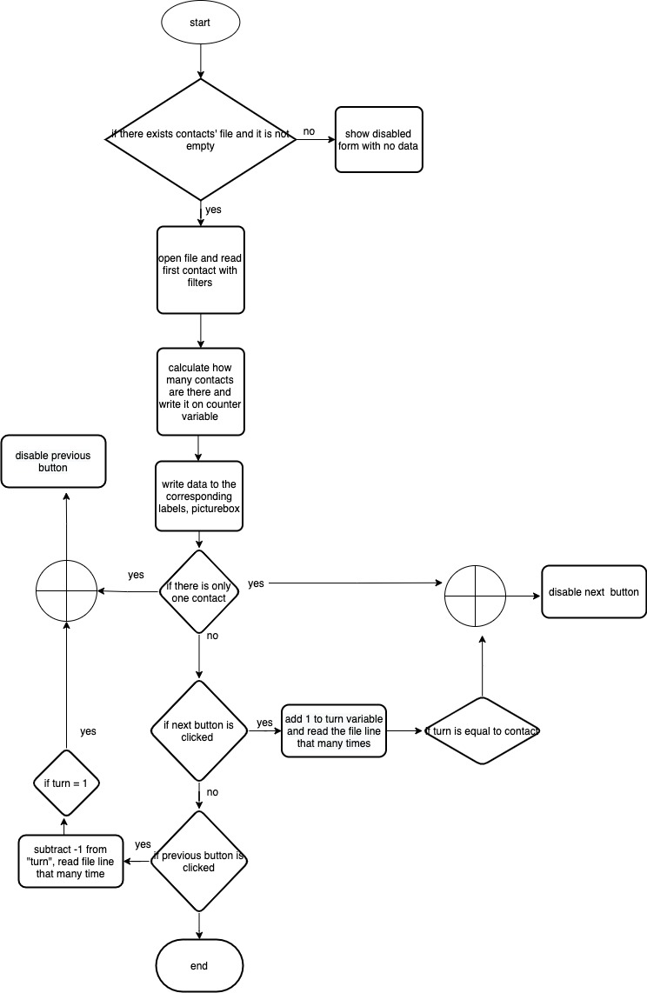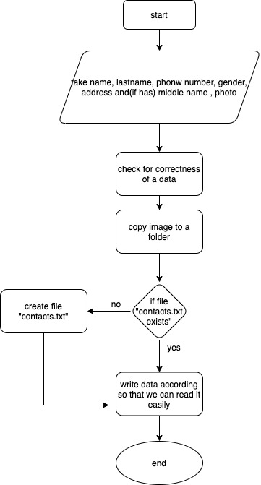

Show contacts flowchart

Save contacts flowchart